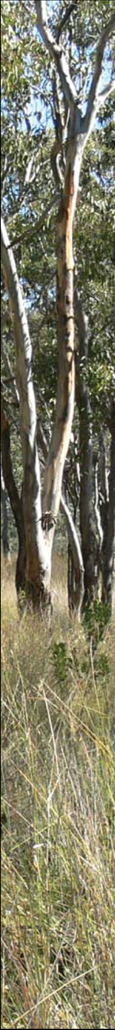
From 2017 to 2020 Bowning-Bookham Districts Landcare is partnering with the NSW Environmental Trust to share funding and support with landholders to fence existing trees and plant new tree plots. We are also holding field days, wildlife surveys and community plantings and events, and can source direct seeding equipment.
The Environmental Trust grant funds:
- From $5 p.metre for fencing (materials or labour);
- our Landcare Nursery to provide you with tubestock to plant or
seed for direct seeding; and,
- experts and materials for field days, wildlife surveys and events.
The purpose of this support is to improve farm productivity at the same time as creating healthy habitat hops across the District.
To access the Environmental Trust funding landholders need to be in the zone between Burrunjuck Nature Reserve Park and Bango State Forest (see over for map), join the Landcare group, and agree to:
- plan the tree plots for your property;
- assist with seed collection, sowing native or seedling maintenance;
- prepare, fence and plant tree plots;
- monitor progress with photos and notes for three years; and
- temporary or better protection of tree plots as per NSW government guidelines.
We’d also appreciate it if you would host a walk’n’talk on your property and share your experience at our meetings.
The aim of Bowning-Bookham Districts Landcare’s ongoing paddock trees project is to work together to add low-maintenance paddock trees and shelter belts to our landscape for the benefit of our families, our farms, our local and visiting birds and animals, and to preserve our history and environment.
For further information contact Elizabeth Goodfellow on 0437 178 357

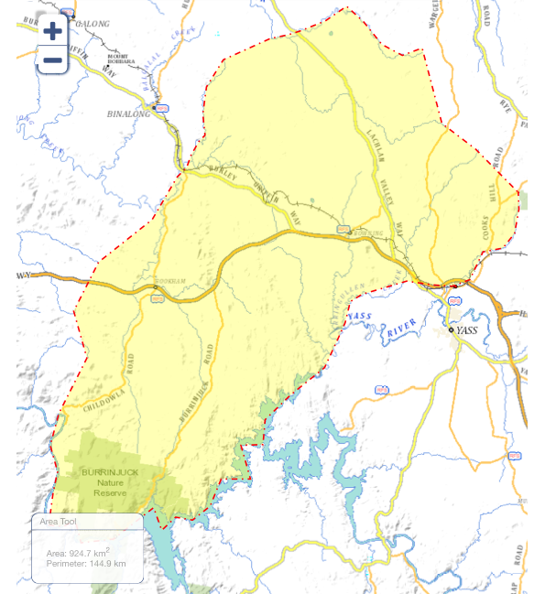
Rules of Thumb for Tree Plots
Beautiful, functional AND productive.
- Bigger plots are better (but some is better than none).
- Shelter belts against prevailing wind help pasture, stock, people and habitat the most.
- Mixed/diverse plants last longer.
- More trees in an area is better than none (so don’t worry about spacing of plants).
- Native trees are better for native birds.
- Consider fire-retardant/non-natives for around key assets/buildings.
- Use fine/feathery plants to discourage pest/aggressive birds that raid nests and out-compete the other birds.
- Thinning/cool-burning every 5-10 years helps get regrowth/saves replanting.
- Where’s your sanity paddock and how healthy is it?

